**Module : English**

**Master One : Mathematics**

**Teacher : Miss. Bellebcir**

**Syllabus of the Second Semester**

**Lecture One : Mathematical Symbols and Geometric Shapes**

**Lecture Two : Analyzing and Interpreting Charts and Graphs**

**Lecture Three : Translation and its Types (Word for Word)**

**Lecture Four :Literal and Communicative Translations**

**Lecture Five :Steps to Write a Scientific Report**

**Lecture One : Mathematical Symbols and Geometric Shaps**

**Part One : Mathematical Symbols**

| **Symbol** | **Symbol Name in Maths** | **Math Symbols Meaning** | **Example** |
| --- | --- | --- | --- |
| **≠** | not equal sign | inequality | 10 ≠ 6 |
| **=** | equal sign | equality | 3 = 1 + 2 |
| **<** | strict inequality | less than | 7 < 10 |
| **>** | strict inequality | greater than | 6 > 2 |
| **≤** | inequality | less than or equal to | x ≤ y, means, y = x or y > x, but not vice-versa. |
| **≥** | inequality | greater than or equal to | a ≥ b, means, a = b or a > b, but vice-versa does not hold true. |
| **[ ]** | brackets | calculate expression inside first | [ 2×5] + 7 = 10 + 7 =  17 |
| **( )** | parentheses | calculate expression inside first | 3 × (3 + 7) = 3 × 10 = 30 |
| **−** | minus sign | subtraction | 5 − 2 = 3 |
| **+** | plus sign | addition | 4 + 5 = 9 |
| **∓** | minus – plus | both minus and plus operations | 1 ∓ 4 = -3 and 5 |
| **±** | plus – minus | both plus and minus operations | 5 ± 3 = 8 and 2 |
| **×** | times sign | multiplication | 4 × 3 = 12 |
| **\*** | asterisk | multiplication | 2 * 3 = 6 |
| **÷** | division sign / obelus | division | 15 ÷ 5 = 3 |
| **∙** | multiplication dot | multiplication | 2 ∙ 3 = 6 |
| **–** | horizontal line | division / fraction | 8/2 = 4 |
| **/** | division slash | division | 6 ⁄ 2 = 3 |
| **ab** | power | exponent | 24 = 16 |
| **.** | period | decimal point, decimal separator | 4.36 = 4 +(36/100) |
| **√a** | square root | √a · √a = a | √9 = ±3 |
| **a^b** | caret | exponent | 2 ^ 3 = 8 |
| **4√a** | fourth root | 4√a ·4√a · 4√a · 4√a = a | 4√16= ± 2 |
| **3√a** | cube root | 3√a ·3√a · 3√a = a | 3√343 = 7 |
| **%** | percent | 1% = 1/100 | 10% × 30 = 3 |
| **ppm** | per-million | 1 ppm = 1/1000000 | 10ppm × 30 = 0.0003 |
| **‰** | per-mille | 1‰ = 1/1000 = 0.1% | 10‰ × 30 = 0.3 |
| **ppt** | per-trillion | 1ppt = 10-12 | 10ppt × 30 = 3×10-10 |
| **ppb** | per-billion | 1 ppb = 1/1000000000 | 10 ppb × 30 = 3×10-7 |

|  |  |  |  |
| --- | --- | --- | --- |
| **^** | caret / circumflex | and | x ^ y |
| **·** | and | and | x · y |
| **+** | plus | or | x + y |
| **&** | ampersand | and | x & y |
| **|** | vertical line | or | x | y |
| **∨** | reversed caret | or | x ∨ y |
| **X̄** | bar | not – negation | **x̄** |
| **x’** | single-quote | not – negation | x’ |
| **!** | Exclamation mark | not – negation | ! x |
| **¬** | not | not – negation | ¬ x |
| **~** | tilde | negation | ~ x |
| **⊕** | circled plus / oplus | exclusive or – xor | x ⊕ y |
| **⇔** | equivalent | if and only if (iff) | p: this year has 366 days q: this is a leap year p ⇔ q |
| **⇒** | implies | Implication | p: a number is a multiple of 4  q: the number is even  p ⇒ q |
| **∈** | Belong to/is an element of | Set membership | A = {1, 2, 3} 2 ∈ A |
| **∉** | Not element of | Negation of set membership | A={1, 2, 3} 0 ∉ A |
| **∀** | for all | Universal Quantifier | 2n is even ∀ n ∈ **N**  where**N**is a set of Natural Numbers |
| **↔** | equivalent | if and only if (iff) | p: x is an even number  q: x is divisible by 2  p ↔ q |

| **Greek Symbol** | | **Greek Letter Name** | **English Equivalent** | **Pronunciation** |
| --- | --- | --- | --- | --- |
| Upper Case | Lower Case |
| Β | β | Beta | b | be-ta |
| Α | α | Alpha | a | al-fa |
| Δ | δ | Delta | d | del-ta |
| Γ | γ | Gamma | g | ga-ma |
| Ζ | ζ | Zeta | z | ze-ta |
| Ε | ε | Epsilon | e | ep-si-lon |
| Θ | θ | Theta | th | te-ta |
| Η | η | Eta | h | eh-ta |
| Κ | κ | Kappa | k | ka-pa |
| Ι | ι | Iota | i | io-ta |
| Μ | μ | Mu | m | m-yoo |
| Λ | λ | Lambda | l | lam-da |
| Ξ | ξ | Xi | x | x-ee |
| Ν | ν | Nu | n | noo |
| Ο | ο | Omicron | o | o-mee-c-ron |
| Π | π | Pi | p | pa-yee |
| Σ | σ | Sigma | s | sig-ma |
| Ρ | ρ | Rho | r | row |
| Υ | υ | Upsilon | u | oo-psi-lon |
| Τ | τ | Tau | t | ta-oo |
| Χ | χ | Chi | ch | kh-ee |
| Φ | φ | Phi | ph | f-ee |
| Ω | ω | Omega | o | o-me-ga |
| Ψ | ψ | Psi | ps | p-see |

**Part Two : Geometric Shapes**

Polygons

These are made up of line segments and no curves. They are enclosed structures based on different lengths of sides and different angles.

A **quadrilateral** is a plane figure made with four line segments closing in a space. The easiest, fastest way to learn about quadrilaterals is to build one yourself.

An **equilateral polygon** is a polygon which has all sides of the same length. A rhombus is an example of an equilateral polygon.

|  |  |
| --- | --- |
| **Names of Geometric Shapes** | **Figure** |
| Circle  Locus of all points at a fixed distance from a reference central point is called a Circle. | Circle |
| Oval | Oval |
| Triangle  Triangle is a polygon, which is made of three sides and consists of three edges and three vertices. Also, the sum of its internal angles equals to 180o. | Triangle |
| Square  Square is a quadrilateral where all the four sides and angles are equal and the angles at all the vertices are equal to 90° each. | Square |
| Rectangle  A quadrilateral has two pairs of opposite sides equal in length and interior angles are at the right angles. | Rectangle |
| Parallelogram  A parallelogram is a quadrilateral with two pairs of parallel sides and opposite angles are equal in measure. | Parallelogram |
| A rhombus is a quadrilateral (plane figure, closed shape, four sides) with four equal-length sides and opposite sides parallel to each other | Rhombus |
| In geometry, a pentagon is a five-sided polygon with five straight sides and five interior angles that sum up to 540°540°. A pentagon shape is a plane figure, or flat (two-dimensional) 5-sided geometric shape. | Pentagon |
| Hexagon is a six-sided polygon with six straight sides | Hexagon |
| Heptagon | Heptagon |
| Octagon | Octagon |
| Nonagon | Nonagon |
| Decagon | Decagon |

There exist other geometric shapes such as:

|  |  |  |
| --- | --- | --- |
| Cube | https://cdn1.byjus.com/wp-content/uploads/2020/08/ShapeArtboard-1-copy-16.png | A cube is a three-dimensional shape which has 6 faces, 8 vertices and 12 edges. The faces of the cube are square.  Example: A Rubik’s cube |
| Cuboid | Shapes in Maths - Cuboid | A cuboid is also three dimensional solid having 6 faces, 8 vertices and 12 edges but the faces of the cuboid are in a rectangular shape.  Example: Matchbox |
| Cone | Shapes in Maths - Cone | A cone is a solid which has a circular base and narrows smoothly from the surface to the top at a point called apex or vertex.  Example: An icecream cone |
| Cylinder | Shapes in Maths - Cylinder | A cylinder is a 3d solid shape that has two parallel circular bases connected by a curved surface. It has no vertex.  Example: Gas cylinder |
| Sphere | Sphere | A sphere is a round shape in a 3d plane, whose radius is extended to three dimensions (x-axis, y-axis and z-axis).  Example: Ball |

**Types of Angles**:

Acute Angle

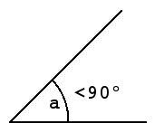

Acute Angle

An acute angle lies between 0 degree and 90 degrees, or in other words; an acute angle is one that is less than 90 degrees. The figure above illustrates an acute angle.

Obtuse Angle

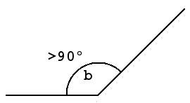

Obtuse Angle

An obtuse angle is the opposite of an acute angle. It is the angle which lies between 90 degrees and 180 degrees or in other words; an obtuse angle is greater than 90 degrees and less than 180 degrees. The figure above illustrates an obtuse angle.

Right Angle

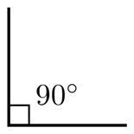

Right Angle

A right angle is always equal to 90 degrees. Any angle less than 90 degrees is an acute angle whereas any angle greater than 90 degrees is an obtuse angle. The figure above illustrates a right angle or a 90-degree angle.

Straight Angle

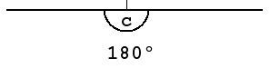

Straight Angle

A straight angle is 180 degrees when measured. The figure above illustrates a straight angle or a 180-degree angle. You can see that it is just a [straight line](https://byjus.com/jee/straight-lines/) because the angle between its arms is 180 degrees.

Reflex Angle

Since this measurement is less than 90 degrees, the arms form an acute angle. But what about the angle on the other side? What is the larger angle that is complementary to the acute angle called? It is called a reflex angle. The image below illustrates a reflex angle.

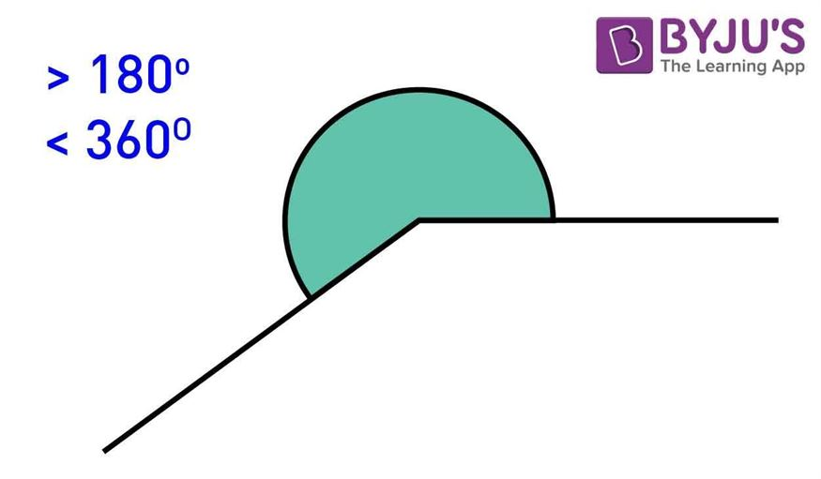

Reflex Angle

Any angle that has a measure which is greater than 180 degrees but less than 360 degrees (which coincides with 0 degrees) is a reflex angle.

### Full Rotation

An angle equal to 360 degrees is called full rotation or full angle. It is formed when one of the arms takes a complete rotation to form an angle.

# Lecture Two: Analyzing and Interpreting Charts

# 

# 1.Types of Graphs and Their Uses

# Every graph is a visual representation of data. This article describes five common types of statistical graphs widely used in any science.

# 1.1Line Graph

# A Line Graph displays data that change. Every Line Graph consists of data points that are connected. The purpose of connecting their lines is to help illustrate a trend, for example, a change or other pattern.

# Uses of Line Graphs:

# 1.When you want to show trends over time, for example, how house prices have increased over time. 2.When you want to show cumulative growth or increase The following Line Graph shows annual sales of a particular business company for the period of six consecutive years:The above Line Graph contains only one line. However, Line Graphs can illustrate more than one set of data, and therefore can contain more than one line.

# 2.Bar Graph

# A Bar Graph represents discrete data with rectangular columns (or bars). Bar Graphs are among the most popular types of graphs in economics, statistics, and marketing. They are commonly used to illustrate categories of data. Each rectangular bar in a Bar Graph has a height corresponding to the values that they represent. The x-axis of a Bar Graph presents the discrete categories, and the y-axis shows a measured value.

# Uses of Bar Graphs:

# 1.When you want to display data that are grouped into discrete categories.

# 2.When you want to compare differences among categories

# 

# 3.Pie Chart displays data in a ‘pie-slice’

# format and illustrate proportion. Each pie

# slice represents the size of one category

# relative to the size of other categories

# -- and in proportion to all the categories

# together (the whole pie). Therefore, a Pie Chart illustrates part-whole relationships, and -- for every Pie Chart -- the whole pie should always add up to 100%.

# 1.When you want to create and represent the composition of something

# 2.When you want to show percentages or proportional data

# 3.A Pie Chart works best for displaying data from four to seven categories.

# Lecture Three: Translation and its Types

# 1: Word-for-word translation

This type of translation keeps the SL word order; words are translated out of context according to their most common meaning. Such kind of translation can be used as a preliminary translation step but it is not applied in real translation tasks. The following lines are from *The Secret Sharer* by Joseph Conrad with their translation into Arabic following the word-for-word method.

On my right hand there were lines of fishing stakes resembling a mysterious system of half- submerged bamboo fences, incomprehensible in its division of the domain of tropical fishes.

Word-for-word translation will be:

على يميني يد كانت خطوط الصيد حصص تشبه غموض نظام نصف مغمور لبامبو أسيجة غير مستوعب في تقسيمه

لمجال االستوائية األسماك.

Such translation is meaningless to an Arab reader since neither its grammatical structure nor its semantics can help the reader make sense of what he or she reads.

جون كان ال كثيرا حب له أمه وأخواته وعداء لي .هو عذب وعاقب أنا ليس اثنان أو ثالث مرات في األسبوع، ليس مرة أو

اثنتين في اليوم، لكن باستمرار، كل عصب أنا لي خاف هو وكل جزء من اللحم على لي عظم ارتجف عندما هو جاء قريب .

كانت هناك لحظات عندما أنا كنت سيطرت بالرعب هو أو حى.

*2.2. Provide a translation that makes sense of the previous excerpt.*

......................................................................................................................................................................................................................................................................................................................................................................................................................................................................................................................................................................................................................................................................................................................................................................................................................................................................................................................................................................................................................................................................................................................................................................................................................................................................................................................................................................................................................................................................................

..................................................................................................................................................

# 2: Literal translation

This type of translation preserves the grammatical structures of the SL where they are translated into their nearest TL equivalents. It takes place when the SL and TL share parallel structures. Words are translated out of context paying no attention to their connotative meanings. The following example illustrates this point.

To throw dust in the eyes

يلقي التراب في العيون

The word ‘dust’ is translated literally as التراب while the equivalent expression in Arabic is ر’ يذ الرماد في العيون where ‘dust’ is translated into الرماد , ashes.

This choice could be justified by the cultural as well as ecological contexts that are different for both languages. If we take the English idiom *to throw dust in the eyes*, its associative meaning is based on the effect of dust once thrown in someone’s eyes blurring their vision and impeding their ability to see. The same sense is expressed in Arabic by using the equivalent ashes rather than dust. Dust is, therefore, not expected to blur vision and hide reality in the Arabic context. Taking the English setting into consideration, you can rarely talk about deserts or dust storms. Another point has to do with religious rituals where some dust is thrown on the buried person in the grave.

***Exercise 1: 1.1.*** *Identify examples of literal translation in the following sentences.*

*1.*I am afraid I lost all saved data. We are back to square one.

أخشى أني فقدت كل البيانات المخزنة .عدنا للمربع األول.

...................................................................................................................................

1. Hold your horses; we still have plenty of time.

أمسك خيولك، لدينا الكثير من الوقت.

................................................................................................................................................

***1.2.*** *Provide correct translations for the sentences above.*

.......................................................................................................................................................

.......................................................................................................................................................

.......................................................................................................................................................

.......................................................................................................................................................

# 3: Communicative translation

This type of translation attempts to render the exact contextual meaning of the original text in such a way that both content and language are readily acceptable and comprehensible to the reader. It is particularly suitable when translating conventional formulae or proverbs and it involves some levels of cultural approximation. Communicative translation aspires to create the same effect created by the SL text on the TL reader.

Study the following examples:

Charity begins at home.

األقربون أولى بالمعروف.

Diamonds cut diamonds.

ال يفل الحديد إال الحديد.

Notice here that ‘diamonds’ is rendered by حديد which is equivalent to *iron* in English.

Literal translation would not convey the message here. In Arabic ‘diamond’ has positive associations related to beauty and noble characteristics while iron is associated with strength and physical power. Prophet Mohammad said:" الناس معادن كمعادن الدهب و الفضة خيارهم في الجاهلية خيارهم في الاسلام و ان فقهوا."

This translates as follows: ‘People are like metals such as gold and silver. The good ones before Islam are also good when converted as long as they learn about Islam.’

Diamond, then, is used in Arabic to refer to how good or bad a person is.

*Road signs, greetings and compliments are best rendered by communicative translation as shown in the following examples.

نافذ غير طريق exit: no end, Dead تحويلة Detour:

تنزيل\تحميل\باص موقف load/unload: Bus,

***Exercise 1:*** *1.1. Translate the following English proverbs using communicative translation.*

1. A burnt child dreads the fire.

..................................................................................................................................

1. A cat has nine lives.

..................................................................................................................................

1. Don’t count your chickens before they’re hatched

..................................................................................................................................

1. Let bygones be bygones.

..................................................................................................................................

1. Marriage is a lottery.

...............................................................................................................................

*1.2. Translate the following Arabic proverbs into English using communicative translation.*

**-1**عصفور في اليد وال عشرة على الشجرة.

..................................................................................................................................

**-2**في العجلة الندامة.

..................................................................................................................................

**-3**غاب القط العب يا فار.

..................................................................................................................................

**-4**الطيور على اشكالها تقع.

..................................................................................................................................

**-5**رب ضارة نافعة.

...........................................................................................................................................